ANA-050 Functional Specification
Simpsons Beverages: Auto Attach Recipe Specification and Density Information to Pack V2.0

Document Properties
Authors | Eshan Fernando | Infor M3 Consultant

Approvers | Joe Walker | Solution Architect | Date: 01/12/2025
Approvers | Bevon Raj | Senior Consultant | Date: 01/12/2025

Change Control | Eshan Fernando | Creation | Date: 13/01/2026
Change Control | Eshan Fernando | Changed the way the process is initiated: Based on an event rather than a script. Minor changes to API inputs, elaborated API inputs, couple of new APIs added based on technical feedback | 21/01/2026
Change Control |  |  | Date

Contents
ANA-050 Functional Specification 1
Document Properties 1
Contents 1
Introduction 2
Functional Overview 2
Current process 2
Proposed process 2
Below is the sequence in which APIs are executed. 4
Assumptions & Limitations 20

Introduction
This ANA-050 Functional Specification provides a functional solution for the Auto Attach Recipe Specification and Density Information to Pack V2.0 requested by Simpsons Beverages.
It is not intended to provide technical information. Any supporting technical information can be found in the accompanying ‘TAR-040 Technical Specification’ document, if provided.

The primary objective of this specification is to provide a functional overview of a solution to the proposed modification.

It does not consist of any training material that explains to a detailed level how the deliverables form the functional solution. It is expected that the reader of this document is to have a good understanding of any Infor M3 programs mentioned within this specification.

Functional Overview

Current process
Certain information that is pushed from PLM to M3 regarding recipe items will be relevant for pack items. Currently this information needs maintaining manually in M3 which is additional work for the team. Information such as recipe tests and density information relevant for the pack item will need to be manually attached to the pack item once the recipe item is added to the pack Bill of Material (BoM).

Proposed process
Once a recipe item (Item type Z30) is attached to a pack BOM in PDS002/U1 screen, recipe item specification header and tests will be attached to the pack item, density information on the recipe item will be multiplied based on pack size and attached to the pack item as well as weight checks added to the pack item based on density.

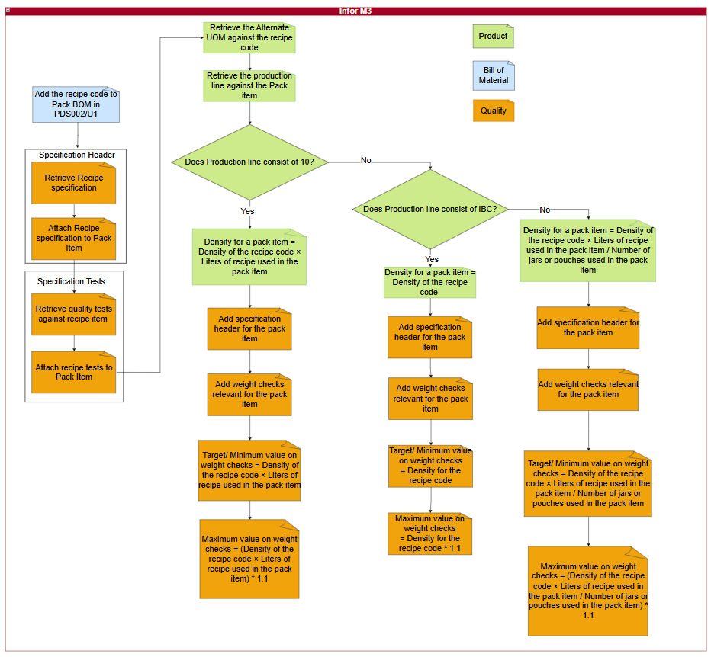
Figure 1: Information on recipes that are relevant for pack items automatically attached.
When a recipe item is added to the product structure for a pack item in PDS002/U1, and the user navigates through PDS002/E and PDS002/F and upon returning to PDS002/U1, the workflow should be triggered. A recipe item is recognized based on ‘item type’ on it being Z30 (MMITTY field in MITMAS table) and ‘item to inherit’ set to 1 (PMINHI field in MPDMAT table).

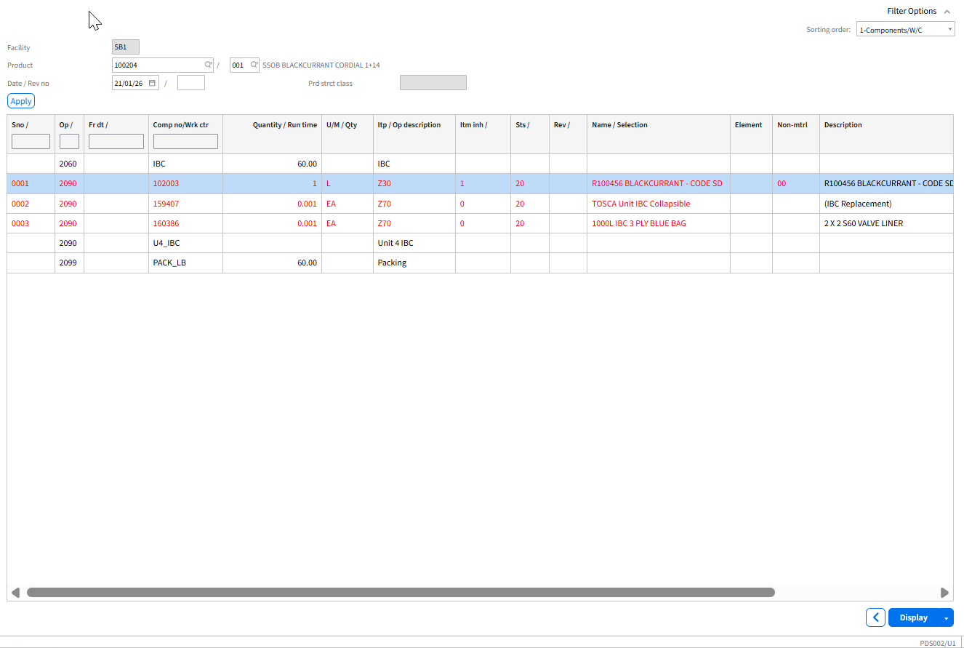
Figure 2: Recipe item in PDS002/U1
It will then execute below APIs in sequence and ensure information on recipe item is attached to the pack item.

Below is the sequence in which APIs are executed.

Step 01: Attaching the recipe specification to pack item

Step 01.01. Retrieving the specification header for the recipe item.
  - API: QMS200MI
  - Transaction: LstSpecsbyItem
Description | Field | Test Value | Extraction Method
Item number | ITNO | 153228 | PMMTNO in MPDMAT table
Table 1: Retrieve specification header for the recipe item.
Based on inputs to Table 1, below outputs are obtained.

Description | Field | Test Value
Specification | SPEC | 153228
Effective date | QSE1 | 20240101
Inactive date | QSI1 | 20301231
Description | TX40 | 153228 Recipe Check
Status | STAT | 20
Auto attach | AUAT | 1
Retest | SRTT | 1
Reclass | SRCL | 1
Laboratory Manager | SPAN | EFERNANDO
Number of copies | NBEX | 1
Table 2: Output retrieved for the recipe item specification.

Step 01.02. Attach specification header record on the recipe item to the pack item
  - API: QMS200MI
  - Transaction: AddSpec
Description | Field | Test Value | Extraction Method
Item number | ITNO | 100194 | PMPRNO in MPDMAT table
Specification | SPEC | 153228 | Output from Table 2
Effective date | QSE1 | 20240101 | Output from Table 2
Inactive date | QSI1 | 20301231 | Output from Table 2
Description | TX40 | 153228 Recipe Check | Output from Table 2
Status | STAT | 20 | Output from Table 2
Auto attach | AUAT | 1 | Output from Table 2
Retest | SRTT | 1 | Output from Table 2
Reclass | SRCL | 1 | Output from Table 2
Laboratory Manager | SPAN | EFERNANDO | Output from Table 2
Number of copies | NBEX | 1 | Output from Table 2
Table 3: Add Recipe specification against the pack item.

Step 02: Attaching tests to the recipe specification attached to pack item

Step 02.01. Retrieve specification tests relating to the specification header for the recipe item.
  - API: QMS201MI
  - Transaction: LstSpecTest
Description | Field | Test Value | Extraction Method
Specification | SPEC | 153228 | Output from Table 2
Effective date | QSE1 | 20240101 | Output from Table 2
Item number | ITNO | 153228 | PMMTNO in MPDMAT table
Table 4: Retrieve specification tests relating to the recipe item.
Based on inputs to Table 4, below outputs are obtained. There will be multiple records retrieved as part of this API call.

Description | Field | Test Value
Test | QTST | DENSITY
Test type | TSTY | 0
Effective date | QTE1 | 20240101
Inactive date | QTI1 | 20301231
Description | TX40 | Density
Test order | EXSQ | 1
Test result | QLCD
Expected value max | EVMX | 1.064
Expected value min | EVMN | 1.024
Expected target value | EVTG | 1.024
Test U/M | TEUM | KGL
Number of decimal places | DCCD | 5
Required | REQD | 1
Frequency times | FRTI | 1
Test classification | TCLS
Value setup | VLTP | 1
Test priority | QTSP | 1
Include test in QI request | ITQR | 1
Print test on certificate of analysis | PTCA | 1
Print test on specification document | PTSP | 1
Print spec test values | QPTT | 1
Print result value | QPTR | 1
Specification approval basis | QPLN | 9
Table 5: Output retrieved for the specification tests for recipe item.

Step 02. 02. Add specification tests to the specification in a loop for each record retrieved from Table 5
  - API: QMS201MI
  - Transaction: AddSpecTest
Description | Field | Test Value | Extraction Method
Specification | SPEC | 153228 | Output from Table 2
Effective date | QSE1 | 20240101 | Output from Table 5
Item number | ITNO | 100194 | PMPRNO in MPDMAT table
Test | QTST | DENSITY | Output from Table 5
Test type | TSTY | 0 | Output from Table 5
Effective date | QTE1 | 20240101 | Output from Table 5
Inactive date | QTI1 | 20301231 | Output from Table 5
Description | TX40 | Density | Output from Table 5
Test order | EXSQ | 1 | Output from Table 5
Test result | QLCD |  | Output from Table 5
Expected value max | EVMX | 1.064 | Output from Table 5
Expected value min | EVMN | 1.024 | Output from Table 5
Expected target value | EVTG | 1.024 | Output from Table 5
Test U/M | TEUM | KGL | Output from Table 5
Number of decimal places | DCCD | 5 | Output from Table 5
Required | REQD | 1 | Output from Table 5
Frequency times | FRTI | 1 | Output from Table 5
Test classification | TCLS |  | Output from Table 5
Value setup | VLTP | 1 | Output from Table 5
Test priority | QTSP | 1 | Output from Table 5
Include test in QI request | ITQR | 1 | Output from Table 5
Print test on certificate of analysis | PTCA | 1 | Output from Table 5
Print test on specification document | PTSP | 1 | Output from Table 5
Print spec test values | QPTT | 1 | Output from Table 5
Print result value | QPTR | 1 | Output from Table 5
Specification approval basis | QPLN | 9 | Output from Table 5
Table 6: Adding specification tests relating to the specification.

Step 03: Adding density against the pack item

Step 03. 01. Retrieving the alternate UOM on the recipe item.
  - API: MMS015MI
  - Transaction: Get
Description | Field | Test Value | Extraction Method
Item number | ITNO | 153228 | PMMTNO in MPDMAT table
Alternate U/M type | AUTP | 1 | Maintain this as a configurable property field so it can be updated or amended as required
Alternate U/M | ALUN | KG | Maintain this as a configurable property field so it can be updated or amended as required
Table 7: Inputs to retrieve unit of measure conversion between Kilograms and Liters on the recipe item.
Description | Field | Test Value
Conversion factor | COFA | 1.032
Conversion form | DMCF | 2
Table 8: Conversion factor and conversion form for the recipe item.
Once the conversion factor (COFA) is retrieved for the recipe item, it needs to be adjusted to calculate density against the pack item based on the production line being 10L, IBC or any other.

Step 03. 02. Retrieving the production line against the pack item.
- API: MMS200MI
  - Transaction: GetItmFac
Description | Field | Test Value | Extraction Method
Company | CONO | 680 | Maintain this as a configurable property field so it can be updated or amended as required
Facility | FACI | SB1 | Maintain this as a configurable property field so it can be updated or amended as required
Item Number | ITNO | 153224 | PMPRNO in MPDMAT table
Table 9: Inputs to extract the production line for the pack item
Description | Field | Test Value
Production line | WCLN | 10L_A
Table 10: Production line against the pack item.

Step 03. 03. Adding the alternate UOM against the pack item.

Step 03. 03. 01. Production line on Table 10 consist of 10 (i.e. 10L_A, 10L_B, 10L_C, U4_10LCD).

Step 03. 03. 01. 01. Extract quantity against the recipe code
  - API: CMS100MI
  - Transaction: LstMaterial
Description | Field | Test Value | Extraction Method
From Item to inherit | F_INHI | 1 | Maintain this as a configurable property field so it can be updated or amended as required
To item to inherit | T_INHI | 1 | Maintain this as a configurable property field so it can be updated or amended as required
Facility | FACI | SB1 | Maintain this as a configurable property field so it can be updated or amended as required
Product | ITNO | 102757 | PMPRNO in MPDMAT table
Structure type | STRT | 001 | Maintain this as a configurable property field so it can be updated or amended as required
Table 11: Inputs to extract the consumption quantity against the recipe code
Description | Field | Test Value
Quantity | CNQT | 20
Table 12: Consumption quantity against the recipe code.

Step 03. 03. 01. 02. Add density against the pack code
  - API: MMS015MI
  - Transaction: Add
Description | Field | Test Value | Extraction Method
Item number | ITNO | 153224 | PMPRNO in MPDMAT table
Alternate U/M type | AUTP | 1 | Maintain this as a configurable property field so it can be updated or amended as required
Alternate U/M | ALUN | DEN | Maintain this as a configurable property field so it can be updated or amended as required
Number of decimal places | DCCD | 6 | Maintain this as a configurable property field so it can be updated or amended as required
Conversion factor | COFA | 20.64 | Conversion factor (COFA) on Table 8 * CNQT value on Table 12
Conversion form | DMCF | 2 | Output from Table 8
Standard U/M - Manufacturing | AUS3 | 0 | Maintain this as a configurable property field so it can be updated or amended as required
Table 13: Inputs to add unit of measure conversion between Kilograms and Liters against pack item.

Step 03. 03. 01. 03. Add specification header to the pack item so that weight checks can be added against the pack item.
  - API: QMS200MI
  - Transaction: AddSpec
Description | Field | Test Value | Extraction Method
Item number | ITNO | 100194 | PMPRNO in MPDMAT table
Specification | SPEC | 100194 | PMPRNO in MPDMAT table
Effective date | QSE1 | 20240101 | Maintain this as a configurable property field so it can be updated or amended as required
Inactive date | QSI1 | 20501231 | Maintain this as a configurable property field so it can be updated or amended as required
Description | TX40 | Pack Check | Maintain this as a configurable property field so it can be updated or amended as required
Status | STAT | 20 | Maintain this as a configurable property field so it can be updated or amended as required
Auto attach | AUAT | 1 | Maintain this as a configurable property field so it can be updated or amended as required
Retest | SRTT | 1 | Maintain this as a configurable property field so it can be updated or amended as required
Reclass | SRCL | 1 | Maintain this as a configurable property field so it can be updated or amended as required
Laboratory Manager | SPAN | EFERNANDO | Maintain this as a configurable property field so it can be updated or amended as required
Number of copies | NBEX | 1 | Maintain this as a configurable property field so it can be updated or amended as required
Table 14: Add Recipe specification against the pack item.

Step 03. 03. 01. 04. Retrieve details relating to weight checks. This needs to be executed 15 times in a loop for tests WEIGHT-A to WEIGHT-O (WEIGHT-A, WEIGHT-B, WEIGHT-C……………., WEIGHT-O)
  - API: CMS100MI
  - Transaction: LstQITest
Description | Field | Test Value | Extraction Method
Test | QSQTST | WEIGHT-A | Maintain this as a configurable property field so it can be updated or amended as required. Needs to be executed in a loop with values from WEIGHT-A to WEIGHT-O (i.e. WEIGHT-A, WEIGHT-B, WEIGHT-C …..WEIGHT-O)
Table 15: Inputs to extract details against weight checks
Description | Field | Test Value
Test | QTST | WEIGHT-A
Test type | TSTY | 0
Effective date | QTE1 | 20240101
Inactive date | QTI1 | 20501231
Description | TX40 | Weight check 1
Test order | EXSQ | 1
Test U/M | TEUM | KG
Number of decimal places | DCCD | 6
Required | REQD | 1
Frequency times | FRTI | 1
Test classification | TCLS
Value setup | VLTP | 1
Test priority | QTSP | 1
Incl tst QI req | ITQR | 1
Prt test on COA | PTCA | 1
Prt tst on spec | PTSP | 1
Prt spc tst val | QPTT | 1
Prt result val | QPTR | 1
Spec appro bas | QPLN | 9
Table 16: Details against weight checks.

Step 03. 03. 01. 05. Specification tests relating to the pack item to the specification. This needs to be run in a loop 15 times for each of the weight checks.
  - API: QMS201MI
  - Transaction: AddSpecTest
Description | Field | Test Value | Extraction Method
Specification | SPEC | 100194 | PMPRNO in MPDMAT table
Effective date | QSE1 | 20240101 | QTE1 output in Table 16
Item number | ITNO | 100194 | PMPRNO in MPDMAT table
Test | QTST | WEIGHT-A | QTST from Table 16. Needs to be executed in a loop with values from WEIGHT-A to WEIGHT-O (i.e. WEIGHT-A, WEIGHT-B, WEIGHT-C …..WEIGHT-O)
Test type | TSTY | 0 | TSTY from Table 16
Effective date | QTE1 | 20240101 | QTE1 from Table 16
Inactive date | QTI1 | 20501231 | QTI1 from Table 16
Description | TX40 | WEIGHT-A | TX40 from Table 16.
Test order | EXSQ | 1 | EXSQ from Table 16.
Test result | QLCD |  | Blank value
Expected value max | EVMX | 22.7 | Conversion factor (COFA) on Table 8 * CNQT value on Table 12 + 10%
Expected value min | EVMN | 20.64 | Conversion factor (COFA) on Table 8 * CNQT value on Table 12
Expected target value | EVTG | 20.64 | Conversion factor (COFA) on Table 8 * CNQT value on Table 12
Test U/M | TEUM | KG | TEUM from Table 16.
Number of decimal places | DCCD | 5 | DCCD from Table 16.
Required | REQD | 1 | REQD from Table 16.
Frequency times | FRTI | 1 | FRTI from Table 16.
Test classification | TCLS | PHYSICAL | TCLS from Table 16.
Value setup | VLTP | 1 | VLTP from Table 16.
Test priority | QTSP | 1 | QTSP from Table 16.
Include test in QI request | ITQR | 1 | ITQR from Table 16.
Print test on certificate of analysis | PTCA | 1 | PTCA from Table 16.
Print test on specification document | PTSP | 1 | PTSP from Table 16.
Print spec test values | QPTT | 1 | QPTT from Table 16.
Print result value | QPTR | 1 | QPTR from Table 16.
Specification approval basis | QPLN | 9 | QPLN from Table 16.
Table 17: Adding specification tests relating to the pack item specification.
Weight check needs to be added to the pack specification 15 times in a loop starting from WEIGHT-A and ending with WEIGHT-O with values being WEIGHT-A, WEIGHT-B, WEIGHT-C,………….WEIGHT-O.

Step 03. 03. 02. Production line on Table 10 consist of any other value except 10 or IBC (i.e. 500ML, 5L_A, 5L_B).

Step 03. 03. 02. 01. Extract quantity against the recipe code
  - API: CMS100MI
  - Transaction: LstMaterial
Description | Field | Test Value | Extraction Method
From Item to inherit | F_INHI | 1 | Maintain this as a configurable property field so it can be updated or amended as required
To item to inherit | T_INHI | 1 | Maintain this as a configurable property field so it can be updated or amended as required
Facility | FACI | SB1 | Maintain this as a configurable property field so it can be updated or amended as required
Product | ITNO | 102757 | PMPRNO in MPDMAT table
Structure type | STRT | 001 | Maintain this as a configurable property field so it can be updated or amended as required
Table 18: Inputs to extract the consumption quantity against the recipe code
Description | Field | Test Value
Quantity | CNQT | 20
Table 19: Consumption quantity against the recipe code.

Step 03. 03. 02. 02. Extract quantity against the jar or pouch
  - API: CMS100MI
  - Transaction: LstMaterial
Description | Field | Test Value | Extraction Method
From Critical mtrl | F_CRTM | 1 | Maintain this as a configurable property field so it can be updated or amended as required
To Critical mtrl | T_CRTM | 1 | Maintain this as a configurable property field so it can be updated or amended as required
Facility | FACI | SB1 | Maintain this as a configurable property field so it can be updated or amended as required
Product | ITNO | 102757 | PMPRNO in MPDMAT table
Structure type | STRT | 001 | Maintain this as a configurable property field so it can be updated or amended as required
Table 20: Inputs to extract the consumption quantity against the jar or pouch
Description | Field | Test Value
Quantity | CNQT | 4
Table 21: Consumption quantity against the jar or pouch.

Step 03. 03. 02. 03. Add density against the pack code
  - API: MMS015MI
  - Transaction: Add
Description | Field | Test Value | Extraction Method
Item number | ITNO | 153224 | PMPRNO in MPDMAT table
Alternate U/M type | AUTP | 1 | Maintain this as a configurable property field so it can be updated or amended as required
Alternate U/M | ALUN | DPJ | Maintain this as a configurable property field so it can be updated or amended as required
Number of decimal places | DCCD | 6 | Maintain this as a configurable property field so it can be updated or amended as required
Conversion factor | COFA | 5.15 | Conversion factor (COFA) on Table 8 * CNQT value on Table 19/ CNQT value on Table 21
Conversion form | DMCF | 2 | Output from Table 8
Standard U/M - Manufacturing | AUS3 | 0 | Maintain this as a configurable property field so it can be updated or amended as required
Table 22: Inputs to add unit of measure conversion between Kilograms and Liters against pack item.

Step 03. 03. 02. 04. Add specification header to the pack item so that weight checks can be added against the pack item.
  - API: QMS200MI
  - Transaction: AddSpec
Description | Field | Test Value | Extraction Method
Item number | ITNO | 100194 | PMPRNO in MPDMAT table
Specification | SPEC | 100194 | PMPRNO in MPDMAT table
Effective date | QSE1 | 20240101 | Maintain this as a configurable property field so it can be updated or amended as required
Inactive date | QSI1 | 20501231 | Maintain this as a configurable property field so it can be updated or amended as required
Description | TX40 | Pack Check | Maintain this as a configurable property field so it can be updated or amended as required
Status | STAT | 20 | Maintain this as a configurable property field so it can be updated or amended as required
Auto attach | AUAT | 1 | Maintain this as a configurable property field so it can be updated or amended as required
Retest | SRTT | 1 | Maintain this as a configurable property field so it can be updated or amended as required
Reclass | SRCL | 1 | Maintain this as a configurable property field so it can be updated or amended as required
Laboratory Manager | SPAN | EFERNANDO | Maintain this as a configurable property field so it can be updated or amended as required
Number of copies | NBEX | 1 | Maintain this as a configurable property field so it can be updated or amended as required
Table 23: Add Recipe specification against the pack item.

Step 03. 03. 02. 05. Retrieve details relating to weight checks. This needs to be executed 15 times in a loop for tests WEIGHT-A to WEIGHT-O (WEIGHT-A, WEIGHT-B, WEIGHT-C……………., WEIGHT-O)
  - API: CMS100MI
  - Transaction: LstQITest
Description | Field | Test Value | Extraction Method
Test | QSQTST | WEIGHT-A | Maintain this as a configurable property field so it can be updated or amended as required. Needs to be executed in a loop with values from WEIGHT-A to WEIGHT-O (i.e. WEIGHT-A, WEIGHT-B, WEIGHT-C …..WEIGHT-O)
Table 24: Inputs to extract details against weight checks
Description | Field | Test Value
Test | QTST | WEIGHT-A
Test type | TSTY | 0
Effective date | QTE1 | 20240101
Inactive date | QTI1 | 20501231
Description | TX40 | Weight check 1
Test order | EXSQ | 1
Test U/M | TEUM | KG
Number of decimal places | DCCD | 6
Required | REQD | 1
Frequency times | FRTI | 1
Test classification | TCLS
Value setup | VLTP | 1
Test priority | QTSP | 1
Incl tst QI req | ITQR | 1
Prt test on COA | PTCA | 1
Prt tst on spec | PTSP | 1
Prt spc tst val | QPTT | 1
Prt result val | QPTR | 1
Spec appro bas | QPLN | 9
Table 25: Details against weight checks.

Add specification tests relating to the pack item to the specification
  - API: QMS201MI
  - Transaction: AddSpecTest
Description | Field | Test Value | Extraction Method
Specification | SPEC | 100194 | PMPRNO in MPDMAT table
Effective date | QSE1 | 20240101 | QTE1 output in Table 25
Item number | ITNO | 100194 | PMPRNO in MPDMAT table
Test | QTST | WEIGHT-A | QTST from Table 25. Needs to be executed in a loop with values from WEIGHT-A to WEIGHT-O (i.e. WEIGHT-A, WEIGHT-B, WEIGHT-C …..WEIGHT-O)
Test type | TSTY | 0 | TSTY output in Table 25
Effective date | QTE1 | 20240101 | QTE1 output in Table 25
Inactive date | QTI1 | 20501231 | QTI1 output in Table 25
Description | TX40 | WEIGHT-A | TX40 output in Table 25
Test order | EXSQ | 1 | EXSQ output in Table 25
Test result | QLCD |  | Blank value
Expected value max | EVMX | 5.67 | Conversion factor (COFA) on Table 8 * CNQT value on Table 19/ CNQT value on Table 21 + 10%
Expected value min | EVMN | 5.15 | Conversion factor (COFA) on Table 8 * CNQT value on Table 19/ CNQT value on Table 21
Expected target value | EVTG | 5.15 | Conversion factor (COFA) on Table 8 * CNQT value on Table 19/ CNQT value on Table 21
Test U/M | TEUM | KG | TEUM output in Table 25
Number of decimal places | DCCD | 5 | DCCD output in Table 25
Required | REQD | 1 | REQD output in Table 25
Frequency times | FRTI | 1 | FRTI output in Table 25
Test classification | TCLS | PHYSICAL | TCLS output in Table 25
Value setup | VLTP | 1 | VLTP output in Table 25
Test priority | QTSP | 1 | QTSP output in Table 25
Include test in QI request | ITQR | 1 | ITQR output in Table 25
Print test on certificate of analysis | PTCA | 1 | PTCA output in Table 25
Print test on specification document | PTSP | 1 | PTSP output in Table 25
Print spec test values | QPTT | 1 | QPTT output in Table 25
Print result value | QPTR | 1 | QPTR output in Table 25
Specification approval basis | QPLN | 9 | QPLN output in Table 25
Table 26: Adding specification tests relating to the pack item specification.
Weight check needs to be added to the pack specification 15 times in a loop starting from WEIGHT-A and ending with WEIGHT-O with values being WEIGHT-A, WEIGHT-B, WEIGHT-C,………….WEIGHT-O.

Step 03. 03. 03. In the event production line on Table 10 consist of a value containing IBC (i.e. IBC, U4_IBC).

Step 03. 03. 03. 01. Add density against the pack code
  - API: MMS015MI
  - Transaction: Add
Description | Field | Test Value | Extraction Method
Item number | ITNO | 153224 | PMPRNO in MPDMAT table
Alternate U/M type | AUTP | 1 | Maintain this as a configurable property field so it can be updated or amended as required
Alternate U/M | ALUN | KG | Maintain this as a configurable property field so it can be updated or amended as required
Number of decimal places | DCCD | 6 | Maintain this as a configurable property field so it can be updated or amended as required
Conversion factor | COFA | 1.032 | Conversion factor (COFA) on Table 8
Conversion form | DMCF | 2 | Output from Table 8
Standard U/M - Manufacturing | AUS3 | 1 | Maintain this as a configurable property field so it can be updated or amended as required
Table 27: Inputs to add unit of measure conversion between Kilograms and Liters against pack item.

Step 03. 03. 03. 02. Add specification header to the pack item so that weight checks can be added
  - API: QMS200MI
  - Transaction: AddSpec
Description | Field | Test Value | Extraction Method
Item number | ITNO | 100194 | PMPRNO in MPDMAT table
Specification | SPEC | 100194 | Product code relating to the recipe selected in PDS002/U1
Effective date | QSE1 | 20240101 | Maintain this as a configurable property field so it can be updated or amended as required
Inactive date | QSI1 | 20501231 | Maintain this as a configurable property field so it can be updated or amended as required
Description | TX40 | Pack Check | Maintain this as a configurable property field so it can be updated or amended as required
Status | STAT | 20 | Maintain this as a configurable property field so it can be updated or amended as required
Auto attach | AUAT | 1 | Maintain this as a configurable property field so it can be updated or amended as required
Retest | SRTT | 1 | Maintain this as a configurable property field so it can be updated or amended as required
Reclass | SRCL | 1 | Maintain this as a configurable property field so it can be updated or amended as required
Laboratory Manager | SPAN | EFERNANDO | Maintain this as a configurable property field so it can be updated or amended as required
Number of copies | NBEX | 1 | Maintain this as a configurable property field so it can be updated or amended as required
Table 28: Add Recipe specification against the pack item.

Step 03. 03. 03. 03. Retrieve details relating to weight checks. This needs to be executed 15 times in a loop for tests WEIGHT-A to WEIGHT-O (WEIGHT-A, WEIGHT-B, WEIGHT-C……………., WEIGHT-O)
  - API: CMS100MI
  - Transaction: LstQITest
Description | Field | Test Value | Extraction Method
Test | QSQTST | WEIGHT-A | Maintain this as a configurable property field so it can be updated or amended as required. Needs to be executed in a loop with values from WEIGHT-A to WEIGHT-O (i.e. WEIGHT-A, WEIGHT-B, WEIGHT-C …..WEIGHT-O)
Table 29: Inputs to extract details against weight checks
Description | Field | Test Value
Test | QTST | WEIGHT-A
Test type | TSTY | 0
Effective date | QTE1 | 20240101
Inactive date | QTI1 | 20501231
Description | TX40 | Weight check 1
Test order | EXSQ | 1
Test U/M | TEUM | KG
Number of decimal places | DCCD | 6
Required | REQD | 1
Frequency times | FRTI | 1
Test classification | TCLS
Value setup | VLTP | 1
Test priority | QTSP | 1
Incl tst QI req | ITQR | 1
Prt test on COA | PTCA | 1
Prt tst on spec | PTSP | 1
Prt spc tst val | QPTT | 1
Prt result val | QPTR | 1
Spec appro bas | QPLN | 9
Table 30: Details against weight checks.

Step 03. 03. 03. 04. Add specification tests relating to the pack item to the specification
  - API: QMS201MI
  - Transaction: AddSpecTest
Description | Field | Test Value | Extraction Method
Specification | SPEC | 100194 | PMPRNO in MPDMAT table
Effective date | QSE1 | 20240101 | QTE1 output in Table 30
Item number | ITNO | 100194 | PMPRNO in MPDMAT table
Test | QTST | WEIGHT-A | QTST from Table 30. Needs to be executed in a loop with values from WEIGHT-A to WEIGHT-O (i.e. WEIGHT-A, WEIGHT-B, WEIGHT-C …..WEIGHT-O)
Test type | TSTY | 0 | TSTY output in Table 30
Effective date | QTE1 | 20240101 | QTE1 output in Table 30
Inactive date | QTI1 | 20501231 | QTI1 output in Table 30
Description | TX40 | WEIGHT-A | TX40 output in Table 30
Test order | EXSQ | 1 | EXSQ output in Table 30
Test result | QLCD |  | Blank value
Expected value max | EVMX | 1.136 | Conversion factor (COFA) on Table 8 + 10%
Expected value min | EVMN | 1.032 | Conversion factor (COFA) on Table 8
Expected target value | EVTG | 1.032 | Conversion factor (COFA) on Table 8
Test U/M | TEUM | KG | TEUM output in Table 30
Number of decimal places | DCCD | 5 | DCCD output in Table 30
Required | REQD | 1 | REQD output in Table 30
Frequency times | FRTI | 1 | FRTI output in Table 30
Test classification | TCLS | PHYSICAL | TCLS output in Table 30
Value setup | VLTP | 1 | VLTP output in Table 30
Test priority | QTSP | 1 | QTSP output in Table 30
Include test in QI request | ITQR | 1 | ITQR output in Table 30
Print test on certificate of analysis | PTCA | 1 | PTCA output in Table 30
Print test on specification document | PTSP | 1 | PTSP output in Table 30
Print spec test values | QPTT | 1 | QPTT output in Table 30
Print result value | QPTR | 1 | QPTR output in Table 30
Specification approval basis | QPLN | 9 | QPLN output in Table 30
Table 31: Adding specification tests relating to the pack item specification.
Weight check needs to be added to the pack specification 15 times in a loop starting from WEIGHT-A and ending with WEIGHT-O with values being WEIGHT-A, WEIGHT-B, WEIGHT-C,………….WEIGHT-O.

Assumptions & Limitations
- A quality specification header and quality specification tests records exists in QMS200 and QMS201 against the recipe item.
- Recipe item is added correctly to the pack BOM with the correct consumption quantity.
- Recipe item is recognized based on item type ‘Z30’ and item to inherit flag against it set to ‘1’.
- Only one recipe code against a pack item.
- Details such as effective dates, inactive dates against weight checks are correct and up to date in QMS100.
- Details on weight checks in QMS100 is the same that applies against pack codes in QMS201.
- Quality specification and density information against the recipe item has already been transferred to Infor Cloudsuite from PLM.
- Quality specification against the pack item is always created in ’20-Approved’ state.

